**Use Cases for data population in Admin**

**Purpose**: this document describes how should be populated data in admin page of BestOperator site.

Initial source of information is operators sites.

**MTS Ukraine**

*Example*: ПЛАНШЕТ 3G

*Link*: <http://www.mts.ua/ua/mobile/tariffs/planshet#terms>

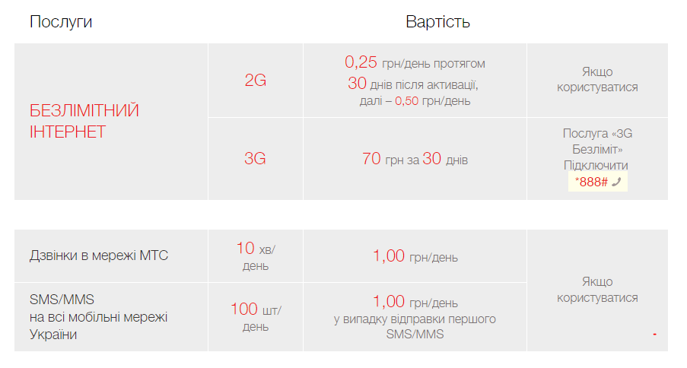

For getting more detailed information you also can use “Variant for printing”



**Steps for data propagations in admin:**

1. Check that operator already exists in data base. Create it if necessary.

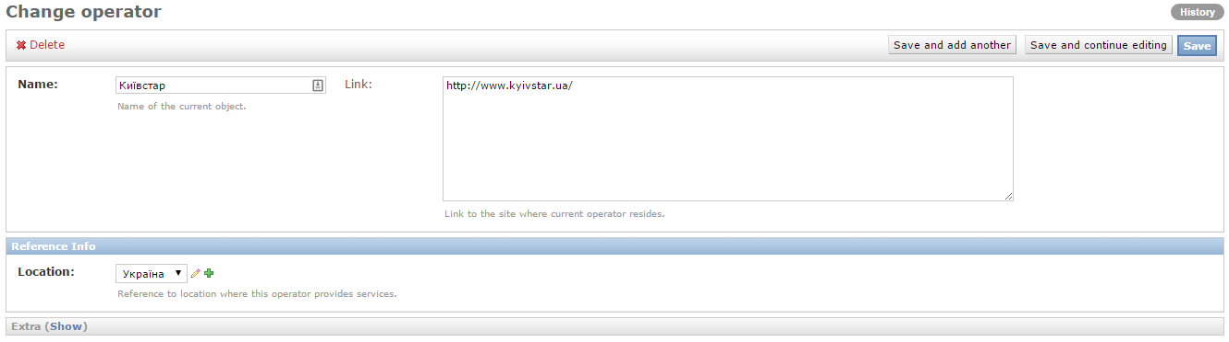

Name and Location is required fields for operator. Link should be populated with URL of main page of official site.

1. Add package name to <Packages> table on Operator page. Use [Add another Package] button.

Populate fields and press [Save] button.

Name of Package is a name of “Тариф”

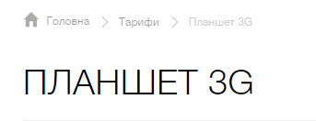

EC: Link field should be compact.

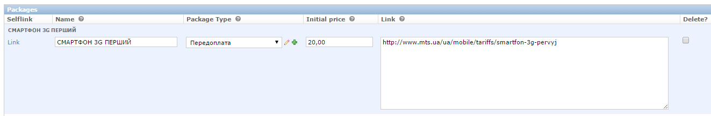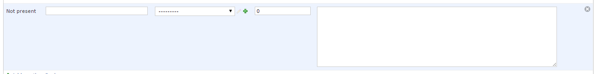

**Tips:** Package price for MTS package is described in Print version of document. ‘Як підключити тариф «Планшет 3G»’ part

1. Open created package

* you can use ‘Change View on site’ button in <Package> table of appropriate Operator page ;
* or navigate to Dashboard, open Packages and open appropriate Package.

Check that all parameters are populated.

EC: Change name of ‘Change View on site’ button.

1. Create Offer (this is ‘Послуга’ on MTS operator site)

In our case Offer is “БЕЗЛІМІТНИЙ ІНТЕРНЕТ”

Click ‘Add another Offer-package relationship’ button in ‘Offer-package relationships’ table on Package page (or open Offers table from Dashboard and click add button)

EC: Offer should contain information about the price on page. It can be Inline. Page should have ability to add payment for each Offer.

For current functionality we should open Payment table and add appropriate records.

In our case there are several prices for current offer. According the information below there are different initial price and per day.

We can see that #1 is a basic price for internet in scope of current package without any prepayment. This internet price is basic for “Планшет 3G” package and should be Internet feature that is linked to Package.

Next per day payments (#2 and #3) have not per day payment, but have different initial payment. It should be separate Offer with different offer-payment (“БЕЗЛІМІТНИЙ ІНТЕРНЕТ 2G”)

3G Безліміт is a separate offer as well.

**2G**

#1 – Initial = 0.0 uah; Daily = 0.25 uah (in case of use) first 30 days and then 0.5 uah for day (in case of use)

#2 – Initial = 10 uah/month; Daily = 0.0 uah

#3 – Initial = 92 uah/year; Daily = 0.0 uah

**3G**

#1 – Initial = 70 uah/month; Daily = 0.0 uah

EC: We don’t have logic how to divide 2G and 3G internet in scope of the same Offer. It can be 2 different features, but in this case there should be different Service Type (like: 2G Internet, 3G internet). Need to discuss.

EC: Got validation message during adding of new Offer under Package. But new objects was added anyway

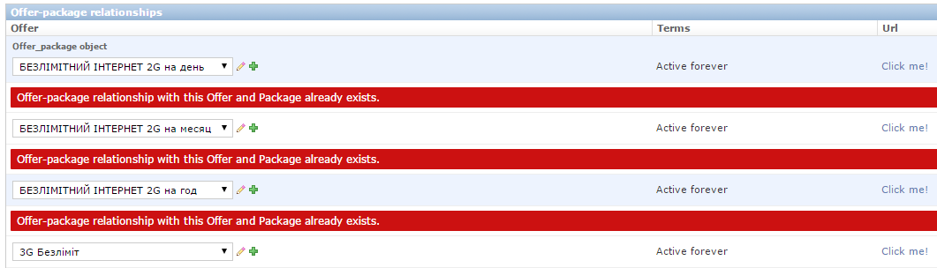

1. Add

## Acronyms:

EC – Expected Changes (green color – low issue, yellow color – normal issue, red color – high issues)